13. ReactJS-HOL

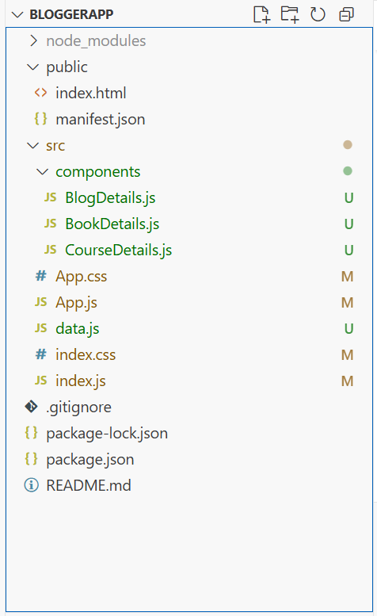

CourseDetails.java
import React from "react";

function CourseDetails({ courses, showCourses }) {
// Conditional rendering using logical &&
return (
<div className="card">
<h2>Course Details</h2>
{showCourses &&
courses.map((course) => (
<div key={course.id}>
<h3>{course.cname}</h3>
<p>{course.date}</p>
</div>
))}
</div>
);
}

export default CourseDetails;

BlogDetails.java
import React from "react";

function BlogDetails({ blogs, showBlogs }) {
if (!showBlogs) {
return (
<div className="card">
<h2>Blog Details</h2>
<p>No blogs available</p>
</div>
);
}

return (

<div className="card">
<h2>Blog Details</h2>
{blogs.map((blog) => (
<div key={blog.id}>
<h3>{blog.title}</h3>
<p><strong>{blog.author}</strong></p>
<p>{blog.content}</p>
</div>
))}
</div>
);
}

export default BlogDetails;

BookDetails.java
import React from "react";
function BookDetails({ books, showBooks })
{
return (
<div className="card">
<h2>Book Details</h2>
{showBooks ? (
books.map((book) => (
<div key={book.id}>
<h3>{book.bname}</h3>
<h4>{book.price}</h4>
</div>
))
) : (

<p>No books to display</p>
)}
</div>
);
}

export default BookDetails;

App.js
import React, { useState } from "react";
import "./App.css";
import { books, blogs, courses } from "./data";
import BookDetails from "./components/BookDetails";
import BlogDetails from "./components/BlogDetails";
import CourseDetails from "./components/CourseDetails";

function App() {

const [showBooks, setShowBooks] = useState(true);
const [showBlogs, setShowBlogs] = useState(true);
const [showCourses, setShowCourses] = useState(true);

return (

<div className="container">
<CourseDetails courses={courses} showCourses={showCourses} />
<BookDetails books={books} showBooks={showBooks} />
<BlogDetails blogs={blogs} showBlogs={showBlogs} />
</div>
);
}

export default App;

